What is Hypothesis

Types of Hypothesis

Null Hypothesis (H0)

Alternative Hypothesis (Ha or H1)

One-Tailed and Two Tailed Tests •

Where H1 is Directional, One-Tailed Test

• Where H1 is Non-Directional, Two-Tailed Test

|  |  |
| --- | --- |
| TYPE OF TESTS | DIFFERENCE |
| One-Tailed Test | Region of Rejection lies entirely in one end of the distribution. Hypothesizing a Range of Values |
| Two Tailed Test | Involves a Critical Region which is split into two equal parts placed in each tail of the distribution. A value of the parameter is being hypothesized. |

|  |  |
| --- | --- |
| Mathematical Formulation of H1 | Region of Rejection |
| Greater Than ( >) | Area of Rejection is placed entirely in the Right Tail of the Distribution |
| Less Than ( < ) | Region of Rejection is in the Left Tail |
| Not Equal To (≠) | Both Tails contain Equal areas serving as Critical Regions |

Each of the following statements is an example of a null hypothesis and alternative hypothesis.

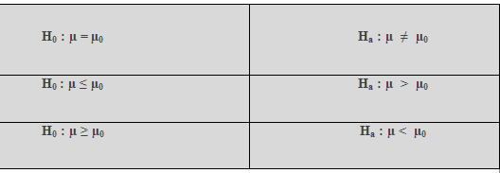



Establish Critical or Rejection region

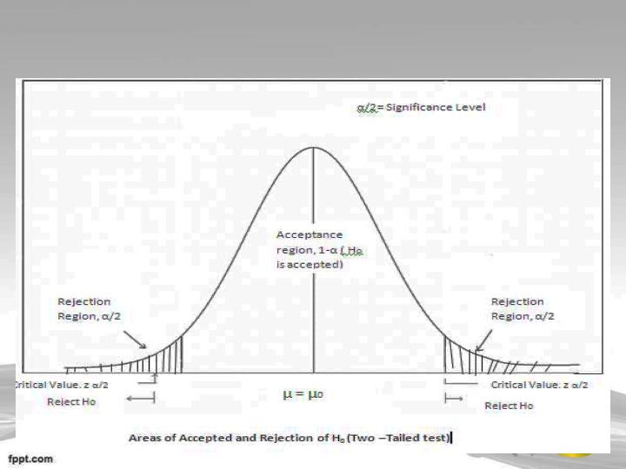

Select the Suitable Test of significance or Test Statistic

Whether the test involves one sample, two samples, or samples?

• Whether two or more samples used are independent or related?

• Is the measurement scale nominal, ordinal, interval, or ratio?

The choice of a probability distribution of a sample statistics is guided but the sample size n and the value of population standard deviation 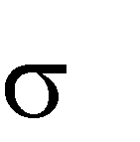as shown in the table.

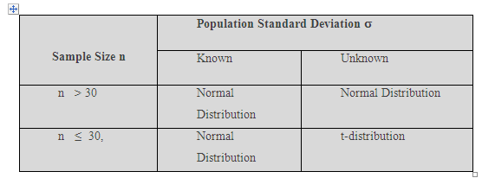

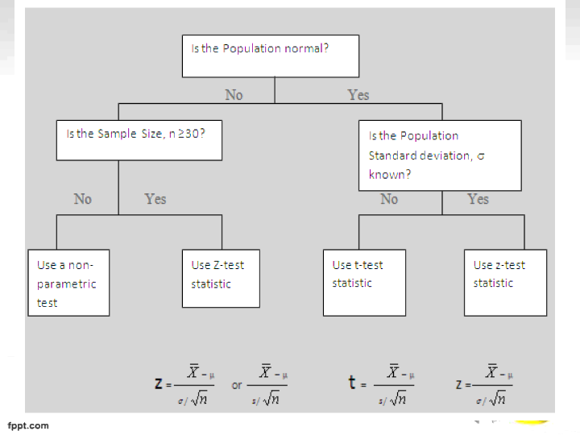

Formulate a Decision Rule to Accept Null Hypothesis

Accept H0 if the test statistic value falls within the area of acceptance.

• Reject otherwise

ERRORS IN HYPOTHESIS TESTING

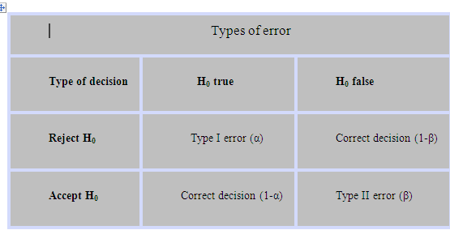

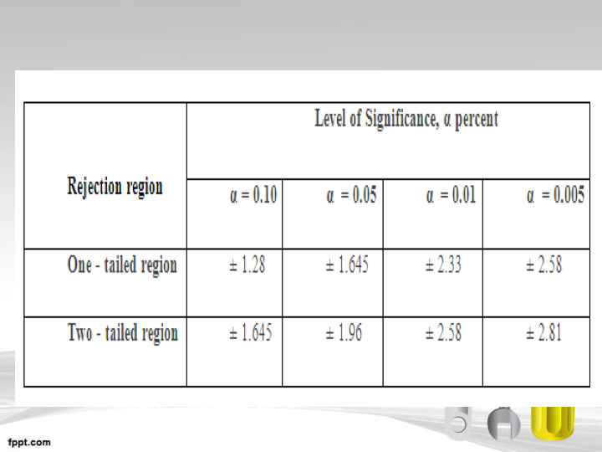

Summary of Certain Values for Sample Statistics Z